Job portal website

Vision Document

Version 1.0

Revision History
Date | Version | Description | Author
19/10/2025 | 1.0 | The initial version of vision document | Trần Nhật Dương
24/10/2025 | 1.1 | The final version of vision document | Trần Nhật Dương

Table of Contents
1. Introduction 4
1.1 Purposes 4
1.2 References 4
2. Positioning 4
2.1 Problem Statement 4
2.2 Product Position Statement 4
3. Stakeholder and User Descriptions 4
3.1 Stakeholder Summary 5
3.2 User Summary 5
3.3 User Environment 5
3.4 Summary of Key Stakeholder or User Needs 5
3.5 Alternatives and Competition 6
4. Product Overview 6
4.1 Product Perspective 6
4.2 Assumptions and Dependencies 6
5. Product Features 6
6. Non-Functional Requirements 7

Vision

Introduction
The introduction of the Vision document provides an overview of the entire document. It includes the purpose and references of this Vision document.

Purposes
The purpose of this document is to define the high level requirement of the employment website system in terms of the needs of end users.

References
Applicable references are:
- System Business Case for the C-Registration System, WyIT388, DRAFT, 1998, Wylie College IT.
- Course Billing Interface Specification, WC93332, 1985, Wylie College Press.
- Course Catalog Database Specification, WC93422, 1985, Wylie College Press.
- Stakeholder Requests Document for the C-Registration System, WyIT389, V1.0, 1998, Wylie College IT.
- Glossary for the C-Registration System, WyIT406, V1.0, 1998, Wylie College IT.
- Requirements Attributes Guidelines for the C-Registration System, WyIT404, V1.0, 1998, Wylie College IT.

Positioning

Problem Statement
The problem of | Inefficient and slow job matching between job seekers and employers
affects | Job seekers and employers
the impact of which is | Waste of time, highly cost and the inefficiency
a successful solution would be | A job portal connects between job seekers and employers quickly and effectively

Product Position Statement
For | Job seekers and employers
Who | Needs an efficient way to find job and hire candidate
The (product name) | InspireLeader
That | Connect both side
Unlike | Traditional way or manual recruitment
Our product | Offer efficient job matching, and a friendly user-interface that make the recruitment process faster

Stakeholder and User Descriptions

Stakeholder Summary

Name | Description | Responsibilities
Developer team | Group of students responsible for building and maintaining the Job Portal system. | Responsible for designing the system architecture and user interface, implementing core features, integrating backend APIs, and conducting testing to ensure the overall functionality and performance of the system
Lecturer | The lectures who supervises and guides the process of development process of the project | Provides guidance, feedback, and evaluation throughout the software development process to ensure the project meets academic and technical requirements.
Admin | The admin of web platform | Manages the web platform, ensures smooth operation, handles user accounts, and maintains system security and stability.
Job seeker | Job seeker | Ensures that the system will meet the needs of Job seekers
Employer | Employer | Ensures that the system will meet the needs of Employer

User Summary

Name | Description | Responsibilities | Stakeholder
Admin | Represents the system administrator who oversees and manages the platform. The admin maintains data integrity, and supervises user and employer activities to ensure compliance with system policies. | Monitor and manage user accounts (job seekers and employers)  Track system statistics (registrations, logins, job posts, revenue)  Review and flag potentially violating job posts  Remove inappropriate posts or accounts with repeated violations | Self - represented
Job seeker | Represents individuals who are looking for job opportunities through the platform. They use the system to search, apply for, and track job postings that match their skills and preferences. | Create and manage personal profiles and resumes  Search and filter available job postings  Apply for desired jobs  Track the status of applications | Self - represented
Employer | Represents companies or organizations that post job openings and review applications. | Create and manage job postings  View and filter candidate applications  Communicate with shortlisted candidates | Self - represented

User Environment
The Job Portal system targets job seekers, employers/recruiters, and administrators, accessible via web browsers on both desktop and mobile devices (Windows, macOS, Linux, Android, iOS).
Job seekers typically work individually to search, apply, and track job applications, while employers may involve multiple recruiters to post jobs and manage applicants. Task durations vary depending on activity, from short searches to longer hiring processes with the cost per day.
The system operates smoothly under different network conditions and device types (mobile, computer, PC, …), ensuring a responsive and user-friendly interface

Summary of Key Stakeholder or User Needs

Need | Priority | Concerns | Current Solution | Proposed solution
Matching between job seekers and employers | High | The traditional method for matching between job seekers and employers /company is time-wasting, inefficient. | Traditionally, job seekers and employers were matched through newspaper ads, job fairs, employment agencies, or personal networks, which made the process slower and less efficient | Serves an online platform which alter the traditional way will meet the demand of both job seeker and employers
Tracking job application status | High | Long time, high difficulty to track the job application status | Applicants often rely on emails or phone calls to check their application status, which is slow and lacks transparency. | Provide an online system that allows users to easily track their job application status in real time.

Alternatives and Competition

Product Overview

Product Perspective
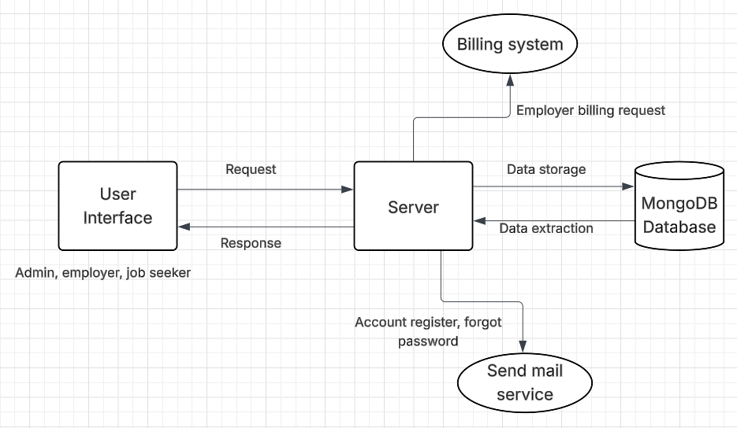

Assumptions and Dependencies
The assumptions and dependencies relates to the capabilities of Job portal website will outline in this Vision document:
- The system will operate continuously, 24 hours a day, 7 days a week.
- The user interface will provide a comfortable and intuitive experience that meets user expectations.
- The website will perform smoothly across web browsers on both computers and mobile devices.

Product Features
User Account Management
- Description: Allows users (job seekers, employers, and admins) to register, log in, log out, and update their account information.
- Purpose: Ensures secure access to the platform and enables users to manage their profiles, enhancing personalization and usability.
- Usability Considerations: The system must provide an intuitive interface for account creation and management, with clear feedback for successful actions (e.g., password updates) and error handling for invalid inputs.
CV Management for Job Seekers
- Description: Enables job seekers to upload, and manage their CVs or resumes within their profiles.
- Purpose: Allows job seekers to present their qualifications effectively to potential employers, streamlining the application process.
- Usability Considerations: The CV upload process provides a preview option to ensure accuracy before submission.
Job Search and Filtering
- Description: Allows job seekers to search and filter job listings based on criteria such as location, salary, job position, and experience level, with the ability to save preferred jobs for later review.
- Purpose: Helps job seekers efficiently find relevant job opportunities that match their skills and preferences.
- Usability Considerations: The search interface must be intuitive, with responsive filtering options and clear presentation of job details to enhance user experience.
Job Application Submission
- Description: Enables job seekers to apply for jobs directly through the portal by submitting their CVs and additional required information.
- Purpose: Simplifies the application process, allowing job seekers to apply to multiple jobs without leaving the platform.
- Usability Considerations: The application process should be straightforward, with confirmation messages upon successful submission and error handling for incomplete applications.
Application Status Tracking
- Description: Allows job seekers to track the status of their job applications (e.g., submitted, under review, accepted, rejected).
- Purpose: Keeps job seekers informed about their application progress, improving transparency and user engagement.
- Usability Considerations: The tracking interface should be clear and accessible, with real-time updates and notifications for status changes.
Job Posting and Management
- Description: Allows employers to create, edit, and manage job postings, including details such as job title, description, requirements, location, and salary range.
- Purpose: Enables employers to advertise job opportunities efficiently and update them as needed to reflect current hiring needs.
- Usability Considerations: The job posting interface should provide templates or guided steps to simplify the process and ensure completeness.
Applicant and CV Review
- Description: Enables employers to view applicant profiles, CVs, and application details, with the ability to label or categorize CVs (e.g., shortlisted, rejected).
- Purpose: Streamlines the recruitment process by allowing employers to efficiently evaluate and manage candidates.
- Usability Considerations: The review interface should allow sorting and filtering of applicants to prioritize candidates based on specific criteria.
Candidate Communication
- Description: Allows employers to respond to applicants (e.g., sending interview invitations or rejection notices) directly through the platform.
- Purpose: Facilitates clear and timely communication between employers and candidates, improving the recruitment experience.
- Usability Considerations: The system should support customizable templates for responses and integrate with email notifications for seamless communication.
Admin Job Posting Management
- Description: Enables administrators to review, approve, or remove job postings to ensure compliance with platform policies.
- Purpose: Maintains the quality and relevance of job listings, ensuring a trustworthy platform for users.
- Usability Considerations: The admin interface should provide a clear overview of all job postings with tools for quick moderation actions.
Notification System
- Description: Allows administrators to send notifications to users (e.g., job alerts for job seekers, updates on job posting status for employers).
- Purpose: Keeps users informed about important updates, enhancing engagement and platform activity.
- Usability Considerations: Notifications should be configurable (e.g., email or in-app) and allow users to opt in or out based on preferences.

Non-Functional Requirements

Attribute | Description | Quality evaluation
Performance | Fast data retrieval and smooth page transition | Response time < 3s
Robustness | System handles invalid inputs and unexpected shutdowns gracefully | 100% recovery within 5 minutes
Security | Data encrypted in transit and at rest | Ensure the security of user
Usability | Simple and intuitive user interface | >85% user satisfaction in testing

